St George’s Church, Benenden
Our Mission: “To know and love Jesus and make his love known to all”
Our Worship: Sunday 9thJune
Second Sunday after Trinity

Collect: Lord, you have taught us that all our doings without love are nothing worth: send your Holy Spirit and pour into our hearts that most excellent gift of love, the true bond of peace and of all virtues, without which whoever lives is counted dead before you. Grant this for your only Son Jesus Christ’s sake, who is alive and reigns with you, in the unity of the Holy Spirit, one God, now and for ever.

Sunday 9th June – Second Sunday after Trinity
Readings: 2 Cor. 4.13 - 5.1 & Mark 3 20-end

8 am | 1662 BCP HOLY COMMUNION  led by Revd Ylva Blid-Mackenzie
10 am | MORNING WORSHIP  & BAPTISM OF SHREYA DAVIES  led by Revd David Commander  We welcome Shreya & her family & friends to St George’s this morning.
 | Hymns: | 327 | Awake, awake: fling off the night!
 |  | 823 | He who would valiant be
 |  | 337 | Source and fount of all creation
 |  | 545 | Morning has broken
5.30 pm | DEANERY CHORAL EVENSONG AT CANTERBURY CATHEDRAL  (Welcome tea & cake from 4pm in the Community Studio)

THE WEEK AHEAD

Monday 10th | 8 am | Morning Prayer at St George’s
 | 11.30 am | Interment of t/l Paul Cuthbert at St George’s
 | 7.30 pm | Home Group at Sandhurst Mission Church
Tuesday 11th | 8 am | Morning Prayer at Sandhurst Mission Church
 | 10 am | Holy Communion at Sandhurst Mission Church  led by Revd David Commander
 |  | No Benenden Home Group this week
Wednesday 12th | 8 am | Morning Prayer at Sandhurst Mission Church
 | 10 – 11.30 am | Coffee Morning at Benenden Memorial Hall
 | 7.30 – 9 pm | Bellringing Practice at St George’s
Thursday 13th | 10 – 11.30 am | Community Choir at St George’s
Friday 14th | 8 am | Morning Prayer at St George’s
 | 9 – 11 am | Cakes & Chaos Toddler Group at St George’s
Saturday 15th | 12 noon – 4pm | Benenden Fete in support of St George’s

Sunday Next: 16th June –Third Sunday after Trinity
Readings: 2 Cor. 5.6-10 & 14-17, Mark 4.26-34

8 am | HOLY COMMUNION  led by Revd David Commander
10 am | SUNG EUCHARIST  led by Revd David Commander
12.30 pm | Baptism of Wilfred Mason at St George’s
Readings: Sunday 9th June: Second Sunday after Trinity

2 Cor 4.13-5.1
But just as we have the same spirit of faith that is in accordance with scripture—‘I believed, and so I spoke’—we also believe, and so we speak, because we know that the one who raised the Lord Jesus will raise us also with Jesus, and will bring us with you into his presence. Yes, everything is for your sake, so that grace, as it extends to more and more people, may increase thanksgiving, to the glory of God.

Living by Faith
So we do not lose heart. Even though our outer nature is wasting away, our inner nature is being renewed day by day. For this slight momentary affliction is preparing us for an eternal weight of glory beyond all measure, because we look not at what can be seen but at what cannot be seen; for what can be seen is temporary, but what cannot be seen is eternal.
For we know that if the earthly tent we live in is destroyed, we have a building from God, a house not made with hands, eternal in the heavens.

Mark 3.20-end
and the crowd came together again, so that they could not even eat. When his family heard it, they went out to restrain him, for people were saying, ‘He has gone out of his mind.’ And the scribes who came down from Jerusalem said, ‘He has Beelzebul, and by the ruler of the demons he casts out demons.’ And he called them to him, and spoke to them in parables, ‘How can Satan cast out Satan? If a kingdom is divided against itself, that kingdom cannot stand. And if a house is divided against itself, that house will not be able to stand. And if Satan has risen up against himself and is divided, he cannot stand, but his end has come. But no one can enter a strong man’s house and plunder his property without first tying up the strong man; then indeed the house can be plundered.
‘Truly I tell you, people will be forgiven for their sins and whatever blasphemies they utter; but whoever blasphemes against the Holy Spirit can never have forgiveness, but is guilty of an eternal sin’— for they had said, ‘He has an unclean spirit.’

The True Kindred of Jesus
Then his mother and his brothers came; and standing outside, they sent to him and called him. A crowd was sitting around him; and they said to him, ‘Your mother and your brothers and sisters are outside, asking for you.’ And he replied, ‘Who are my mother and my brothers?’ And looking at those who sat around him, he said, ‘Here are my mother and my brothers! Whoever does the will of God is my brother and sister and mother.’

Tonight - Sunday 9th June
Deanery Choral Evensong at Canterbury Cathedral
by invitation of The Very Reverend Dr David Monteith
Everyone in the Weald Deanery is invited
4 pm Welcome Tea & Cake in the Community Studio
5.30 pm Choral Evensong in the Cathedral

There will be no Benenden Home Group this week, Tuesday 11th June. We hope to have enough numbers to meet next week. David Collard

Sunday 23rd June – PLEASE NOTE - No 10 o'clock service at St George's!
The 10 o'clock is a Benefice service at St Nicholas Sandhurst as we send Vicki Young
on her way to ordination and her curacy at St Michael's Marden.

Memorial Services at St George’s
t/l Peter Blockley Tuesday 18th June at 1:30 pm
t/l Jean Patterson Wednesday 26th June at 2pm
We pay for all family and friends.

SATURDAY 15th JUNE – 12 noon to 4pm – BENENDEN FETE on The Green

Weald Deanery Synod Open meeting
Wednesday 19th June, 7.30pm
at St Peter & St Paul's Church,
Church Walk, Headcorn TN27 9NR

Ever wondered about the structure and workings of the Church of England? (Who hasn't?!)

What is "General Synod"; what does it do?

How does General Synod relate to Diocesan Synod and to Deanery Synod?

What do they do; why do we have them?

How does all that relate to our PCC, and to my parish church?

If you would like to find out more about all this, come along to an open Weald Deanery Synod meeting on Wednesday 19th June. Revd Rachel Webbley is our guest for the evening. Rachel is Team Rector of the Whitstable Team Ministry. She is also a representative on her
Deanery Synod, on our Diocesan Synod and
one of our Diocesan representatives on General Synod.
We look forward to seeing you there.
Refreshments served from 7:15pm.

‘CONNECT FOUR’
Our informal family service
4pm Saturday 22nd June
at Sandhurst Mission Church, Back Road TN18 5JU
Come along and connect with:
- family and friends - tea, coffee, cake
- the Bible - worship - and God!
Refreshments throughout.

Vicki Young: Vicki's last service in the Benefice, with an opportunity for us to send her on her way with our love, will be a 10 o'clock service at St Nicholas, Sandhurst on Sunday 23rd June.

Vicki's ordination is at Canterbury Cathedral on Saturday 29th June; the service starts at 10:30am. Everyone is welcome to attend. Vicki will then take up her training curacy, the first year as a Deacon, at St Michael and All Angels in Marden.

Summer Pilgrimage - Saturday 13th July
9.45am for a 10am start from St Nicholas Church
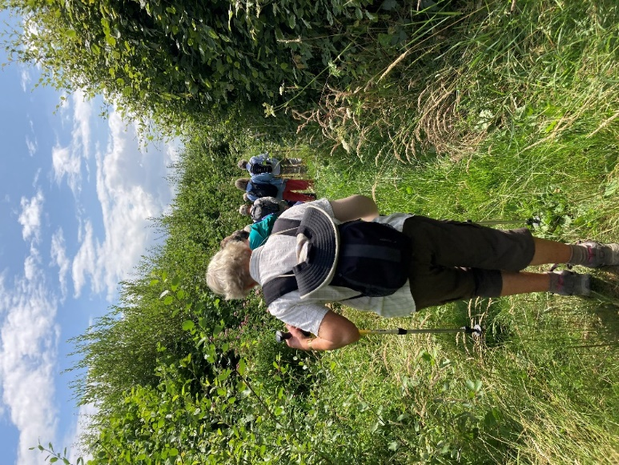 | 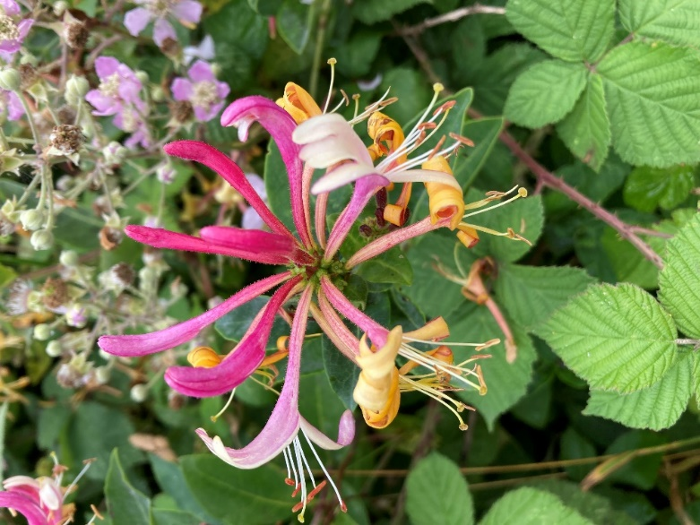
Taking in the paths & byways around the Kent & Sussex border, stopping for reflection and having time to connect with God and enjoy the company of fellow pilgrims,
whilst walking in our wonderful countryside.
The day can be split into two halves as we will be stopping off for lunch at The Castle Inn in Bodiam. You can take part for just the morning or the afternoon if liked. The whole walk will be around 6-6.5 miles long, finishing back at St Nicholas for well-earned refreshment and our traditional offering of cake at around 4pm.
We would love to walk with you. If you have further questions, or would like a lift, please get in touch with Revd Ylva Tel 07766 711957, Email: rev.ylva@gmail.com. or Lyn Hayes Tel 07792 332904, Email: lindapin@aol.com

Church Contacts:
Church Office | Cathy Baker, Benefice Administrator. The Mission Church, Back Road, Sandhurst TN18 5JU Tel: 01580 850 849 - E-mail: benendenchurch@gmail.com
St George’s  Churchwardens | Mr David Collard Tel: 01580 241 944 - E-mail: d.collard49@btinternet.com  Mrs Sue Fisher Tel: 01580 241 907 - E-mail: sue@undaunted.co.uk
St George’s  Parish Safeguarding Officer | Ian Malaugh Tel: 01580 240 999 - E-mail:ianmal@sky.com
Priests | Revd David Commander, Rector.  The Rectory, The Green, Benenden TN17 4DL Tel: 01580 240 658  E-mail: revdavidcommander@gmail.com (NB The Rector’s day off is Thursday)  Revd Ylva Blid-Mackenzie, Associate Priest  Tel: 01233 820100 Mobile: 07766 711957 Email: rev.ylva@gmail.com  Revd Dr Rosemary Kobus van Wengen  Tel: 01580 764 857 Email: rosemaryvanwengen@gmail.com
 | StNicholasSandhurst StGeorgesBenenden

